**Entregable 7**

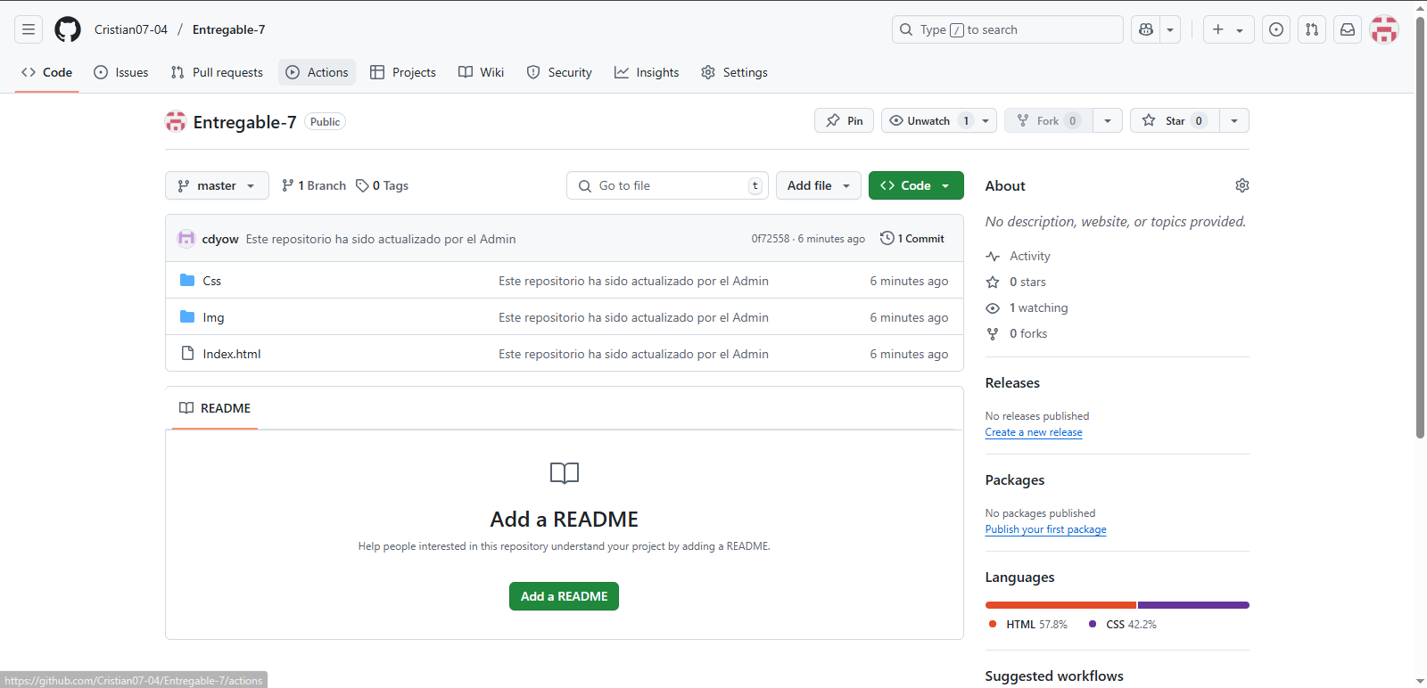

Link del repositorio: <https://github.com/Cristian07-04/Entregable-7.git>